Business Sales Analysis Report
Total Revenue: 10,666,684.54

Key Insights
Top product: DOTCOM POSTAGE (206,248.77 revenue)
Top region: United Kingdom (9,025,222.08 revenue)
Revenue shows strong growth through 2011, peaking in November.

Revenue Trend
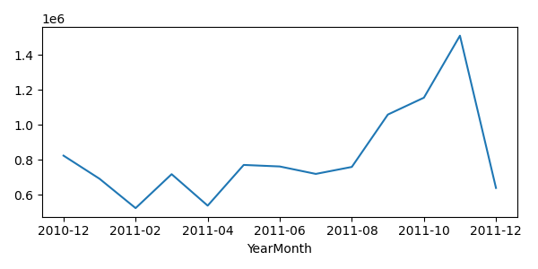

Top Products
